Computer Networks

1. Configuration of Network Devices using Packet Tracer (Hub, Switch, Ethernet, Broadcast)

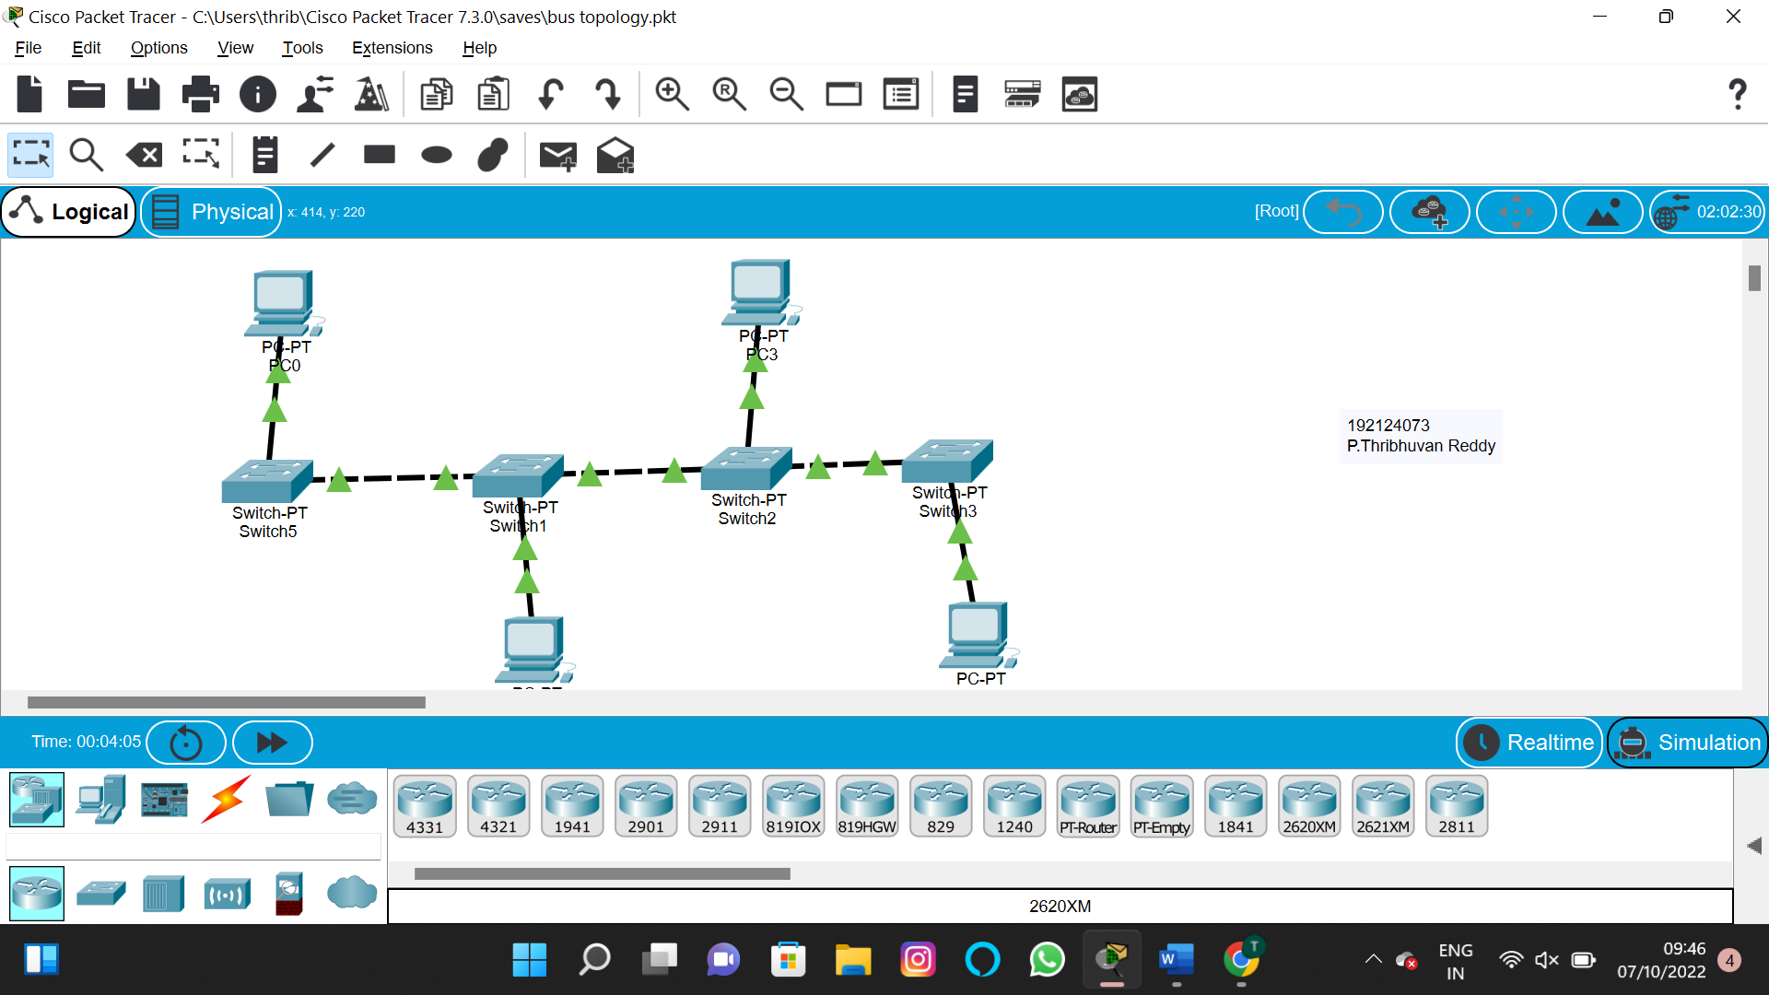

2.Configuration of Topologies using Packet Tracer (Star, Mesh, Tree,)

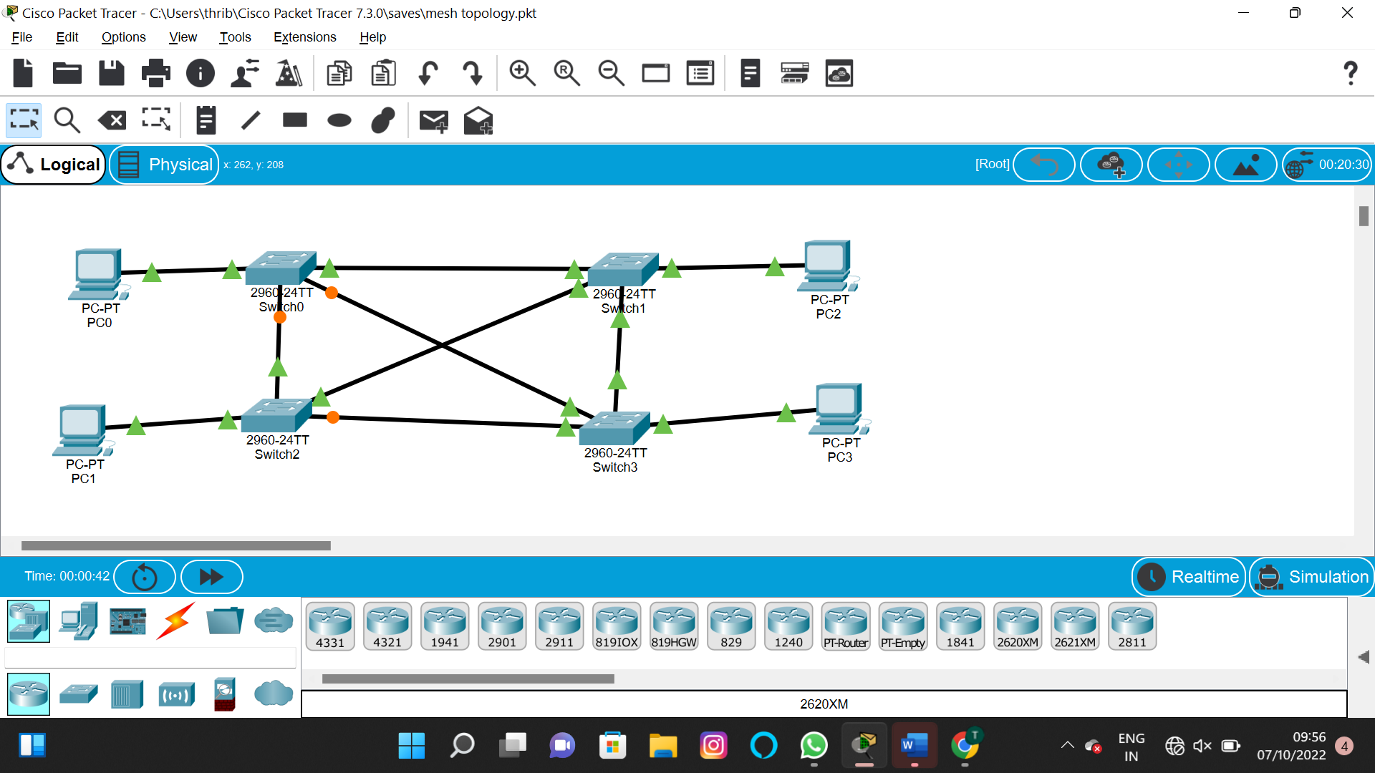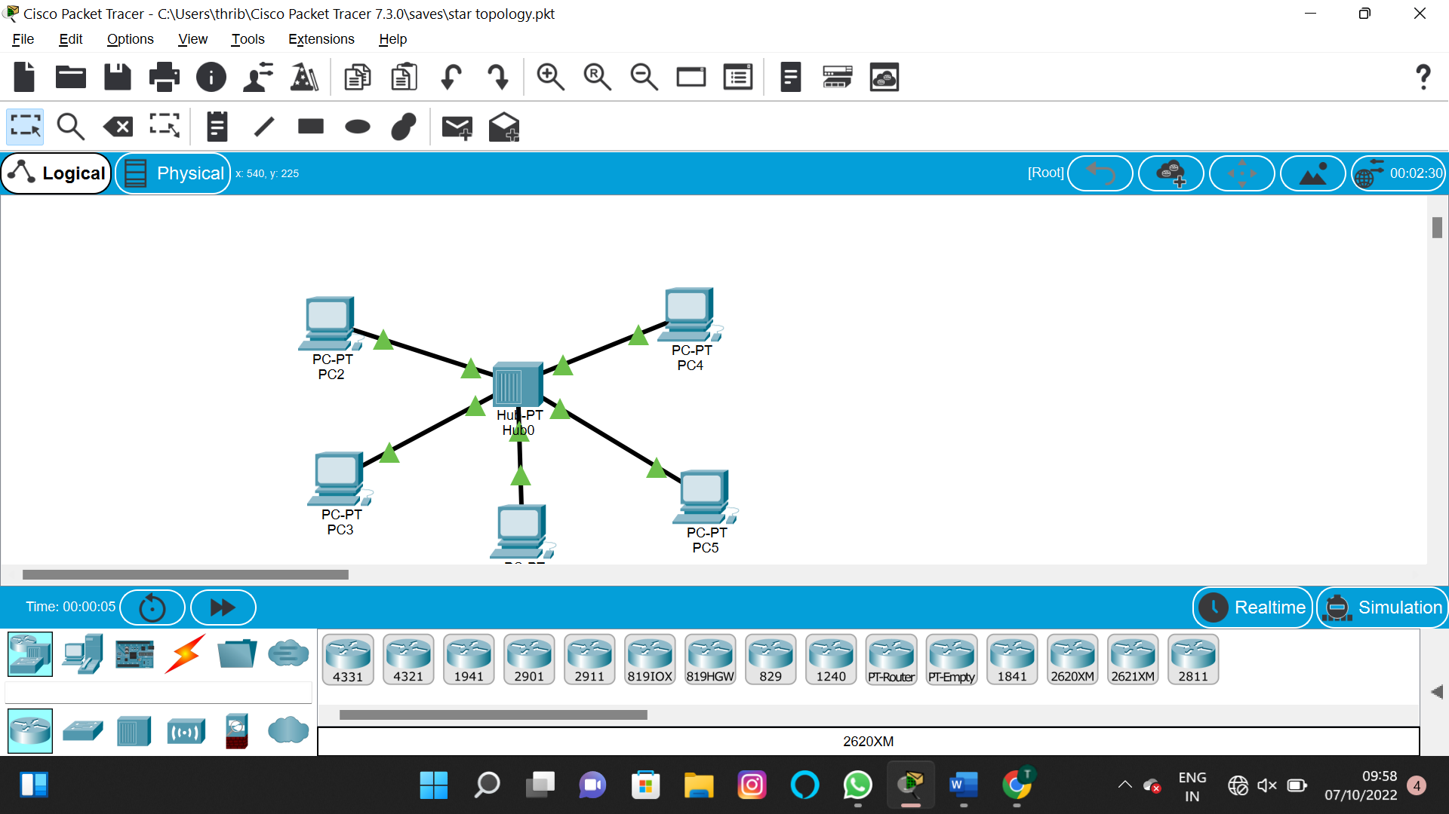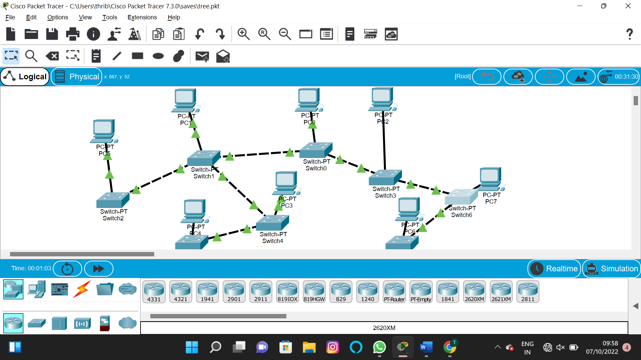

3.Configuration of Topologies using Packet Tracer (Bus, Ring, Hybrid)

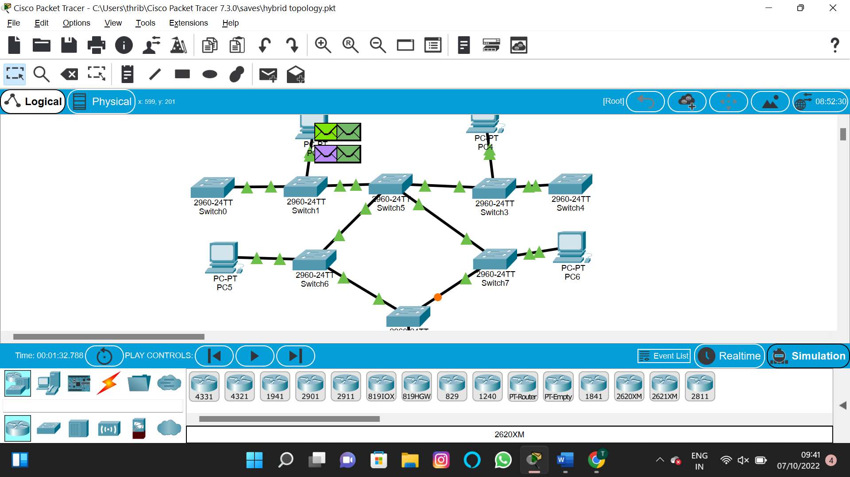



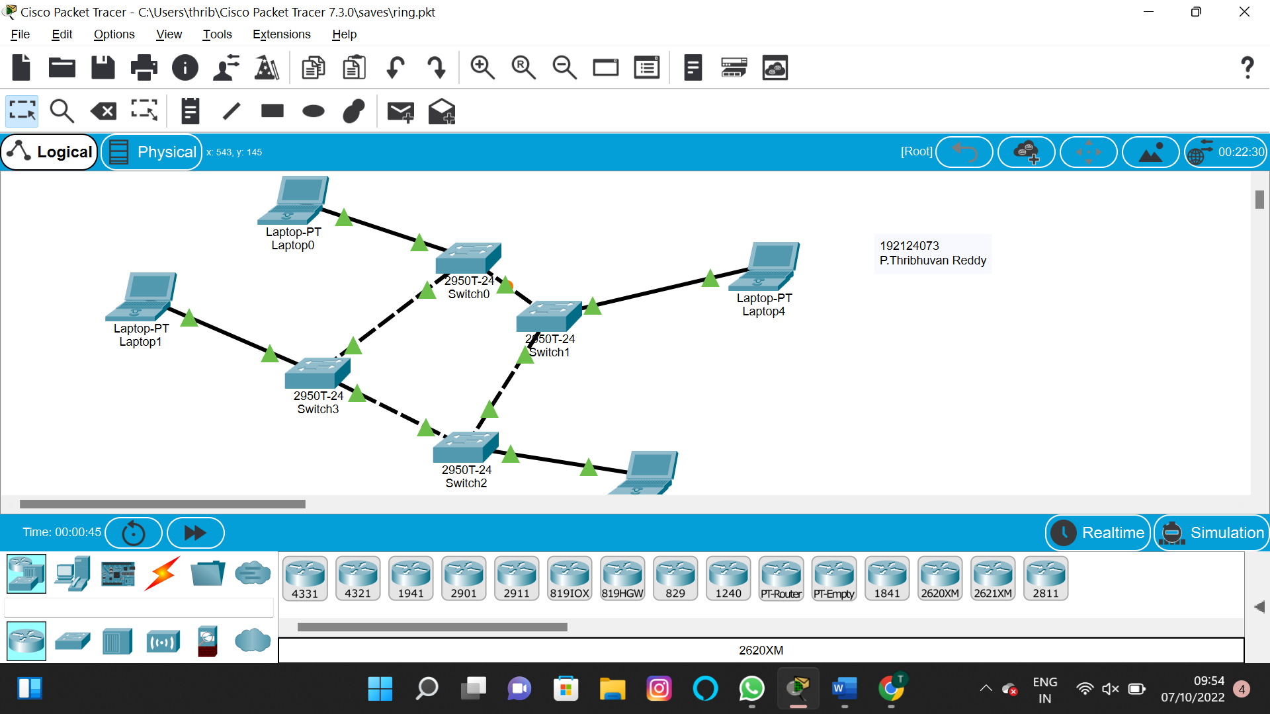

4.Data Link Layer Traffic Simulation using Packet Tracer Analysis of CSMA/CD& CSMA/CA

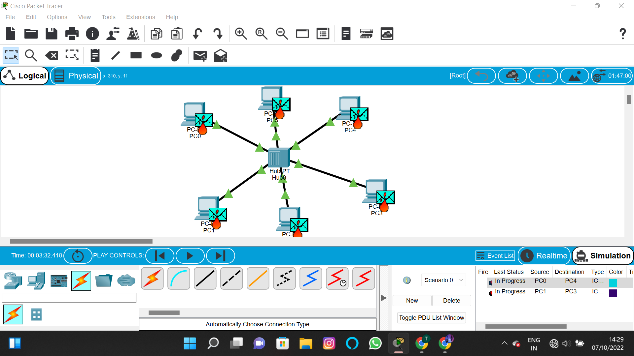

5.Data Link Layer Traffic Simulation using Packet Tracer Analysis of ARP

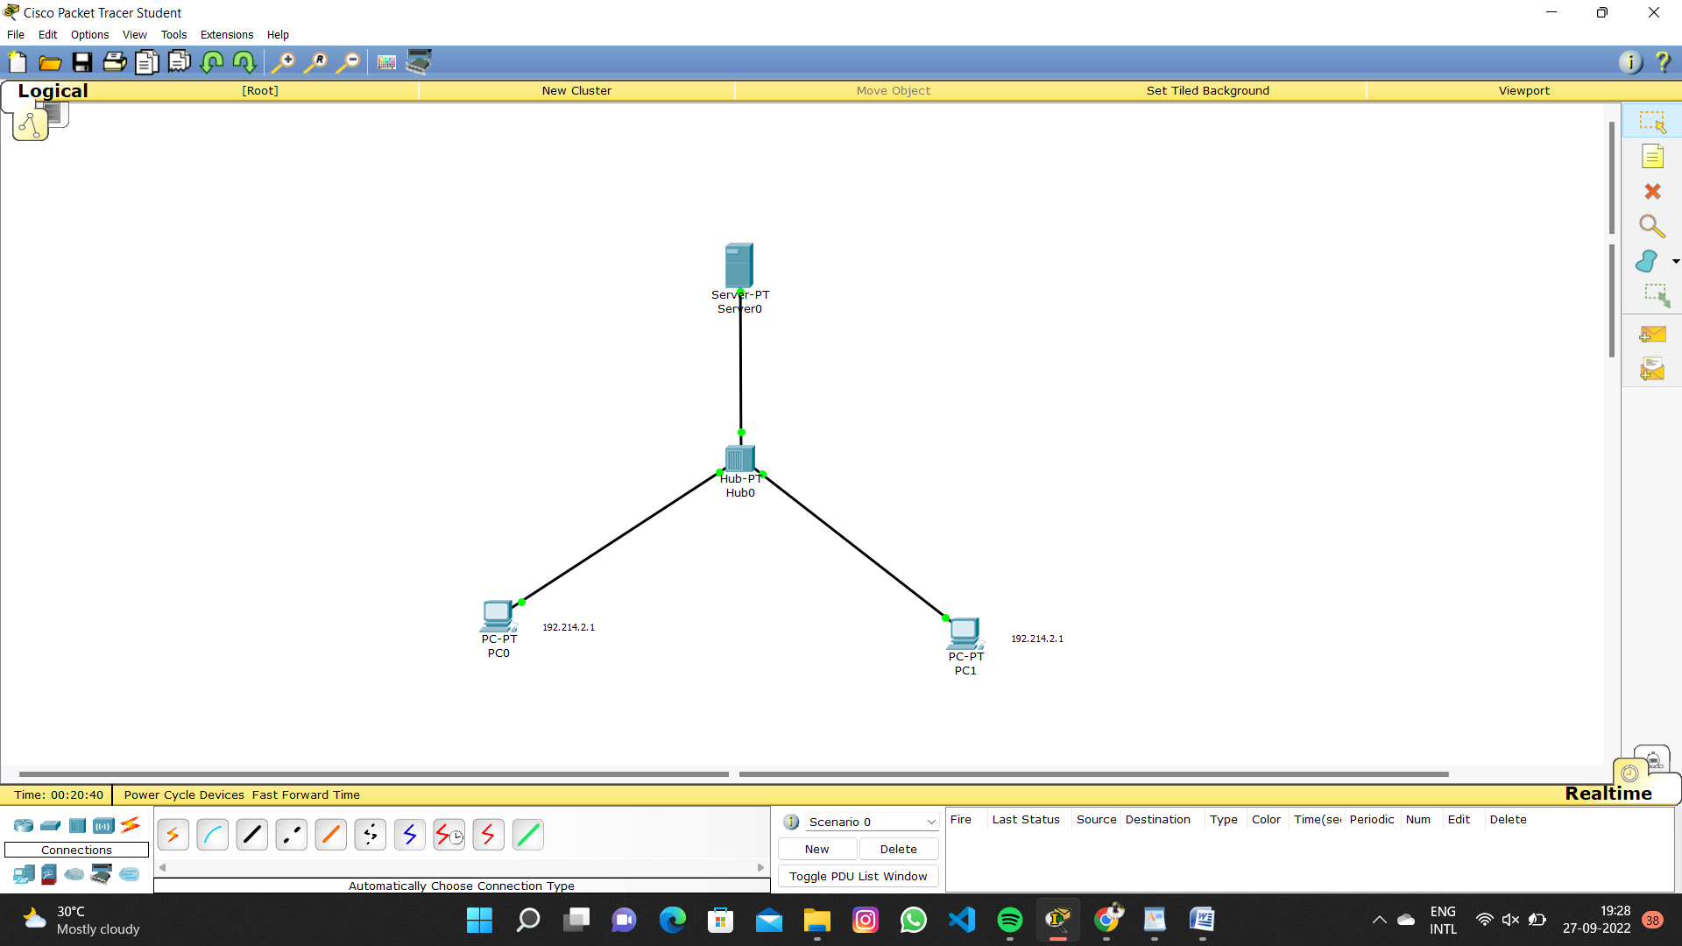

6.Static Routing using Packet Tracer

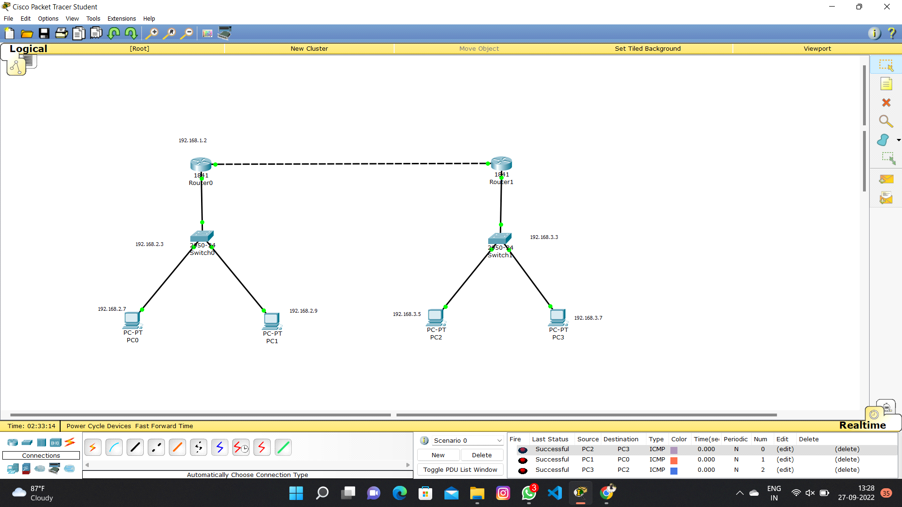

8.Subnetting – Class C Addressing

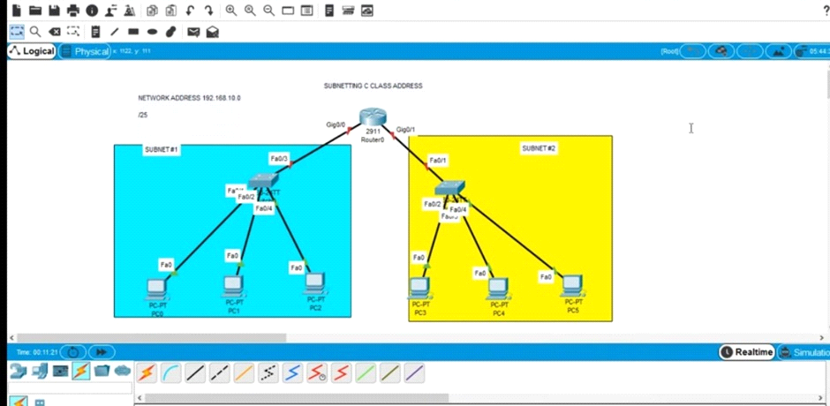

9.Functionalities of TCP, UDP

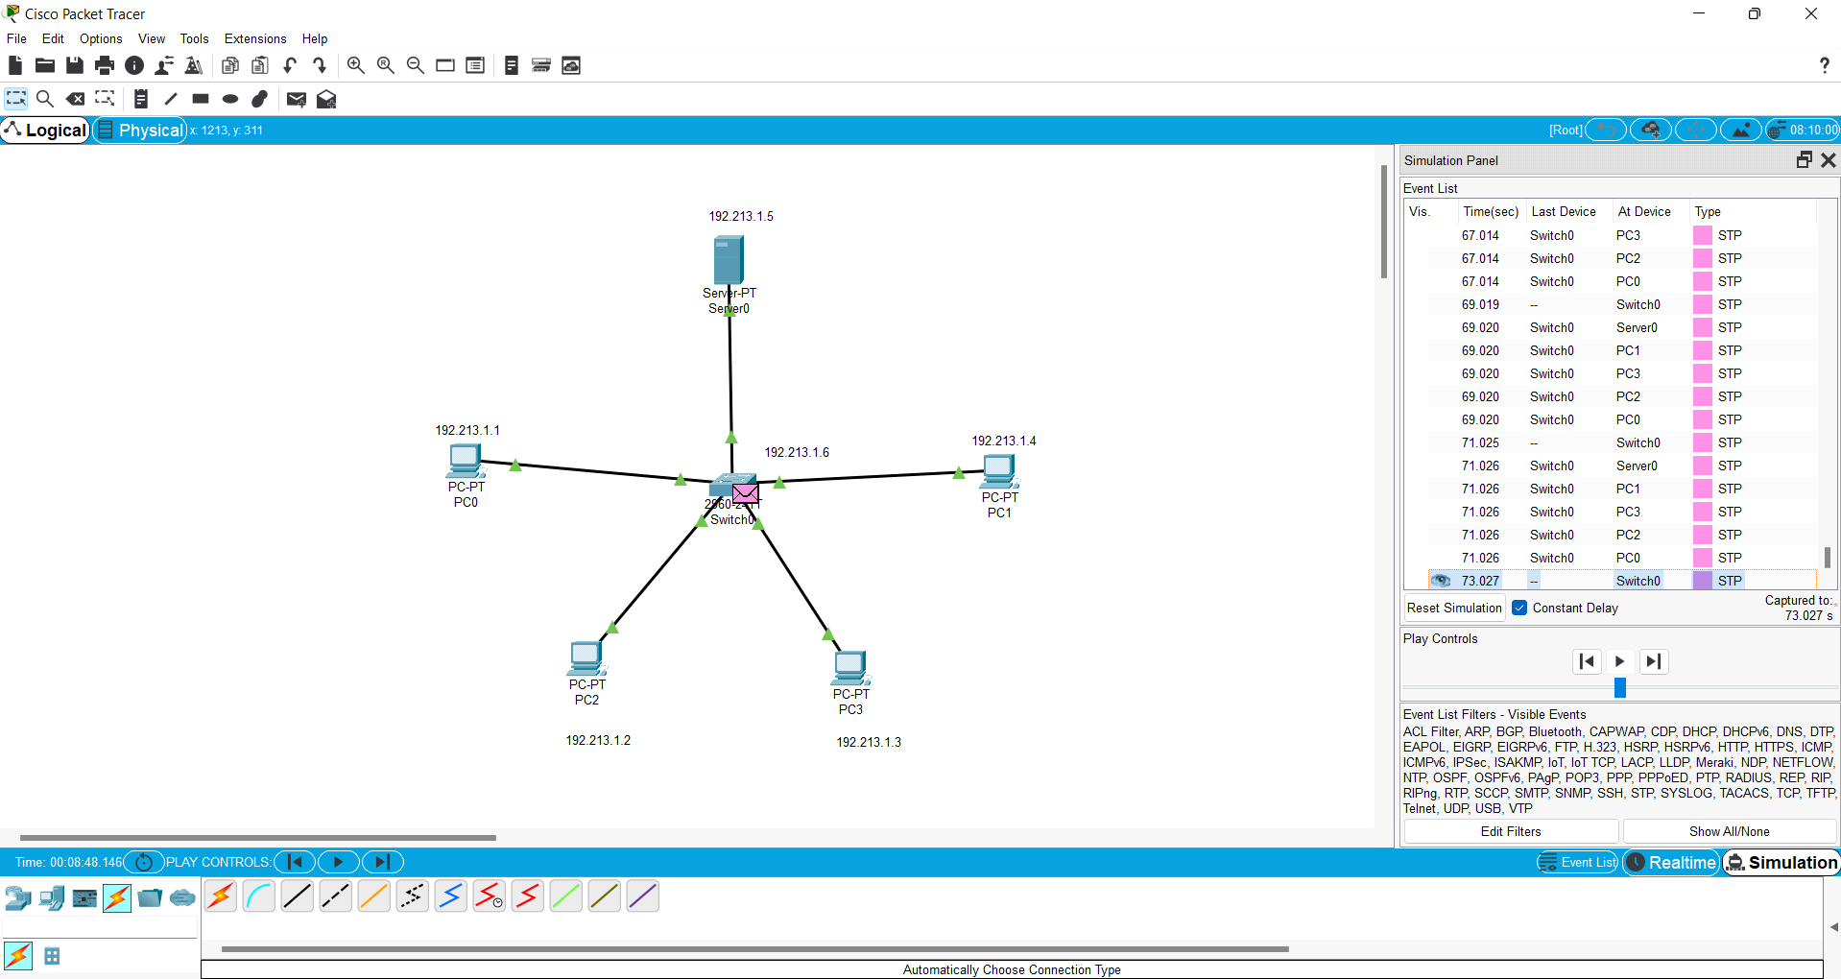

10.TCP, UDP Exploration Solution

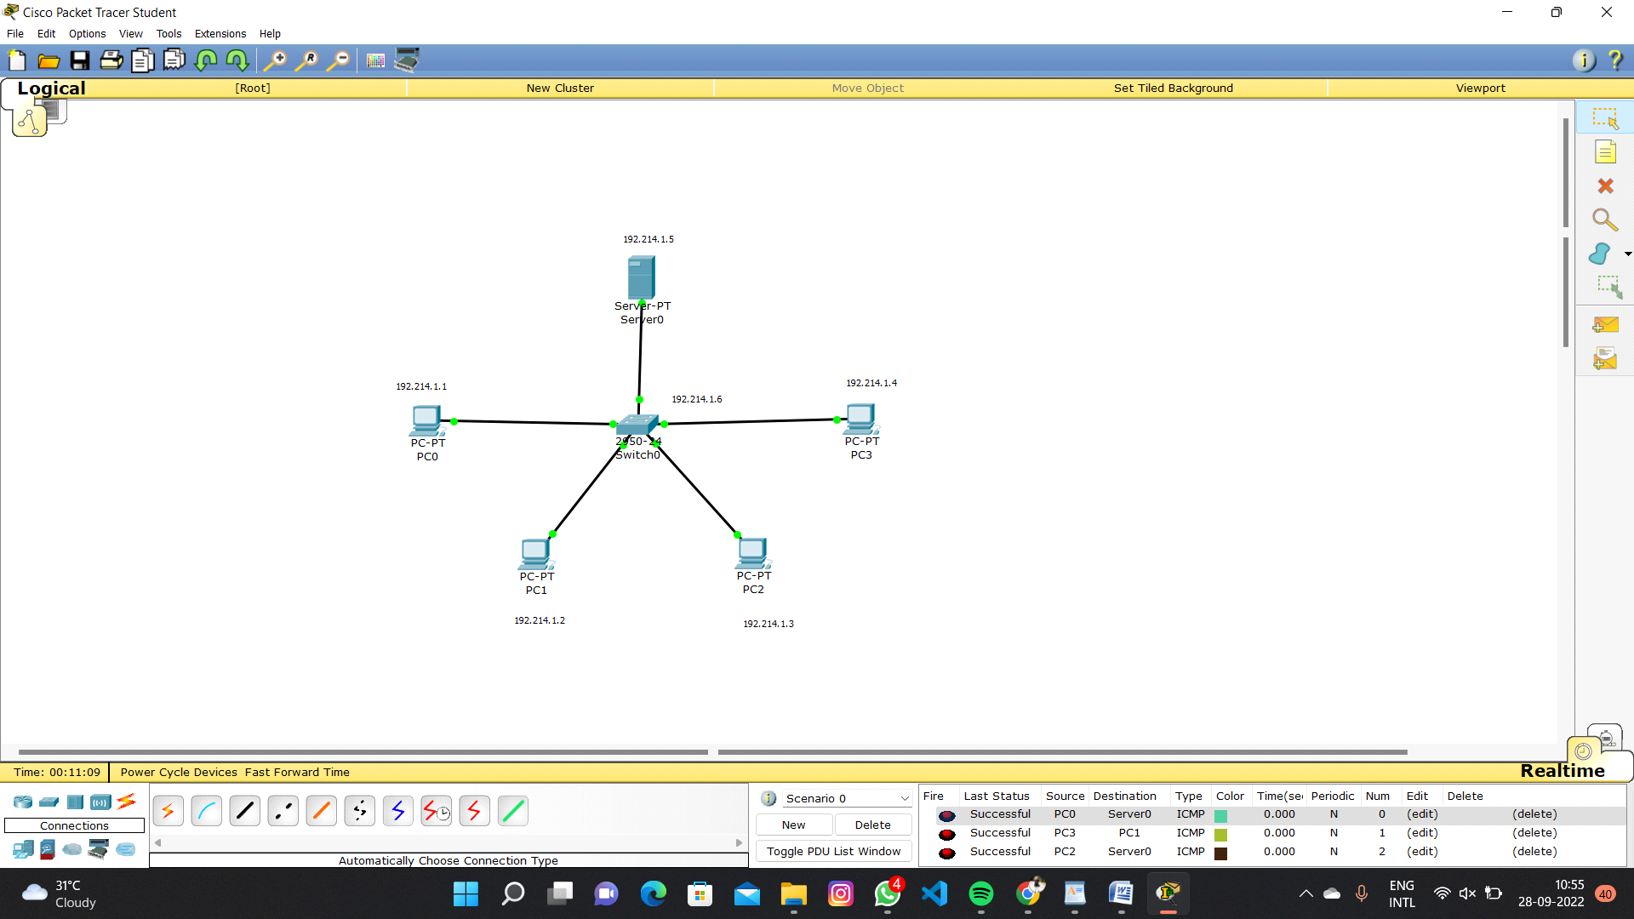

11.IOT Based Smart Home Using Cisco Packet Tracer

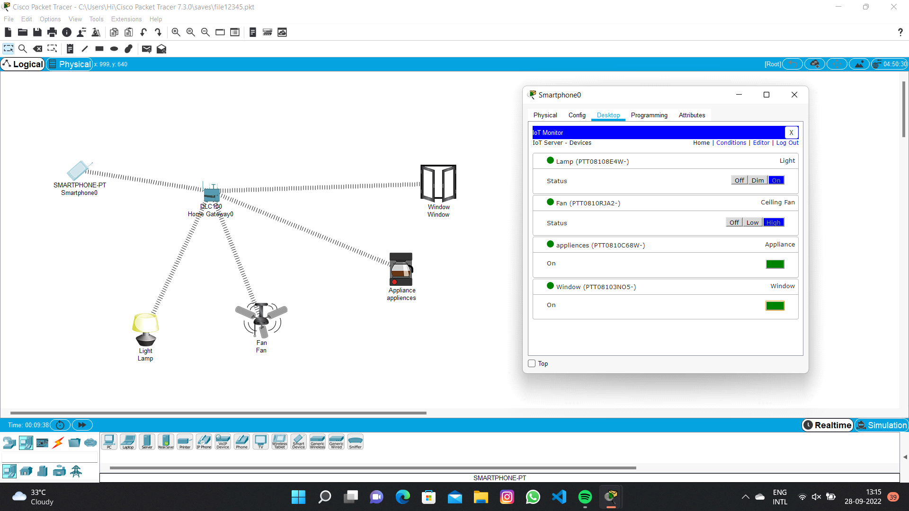

12.Smart Garden in Cisco Packet Tracer

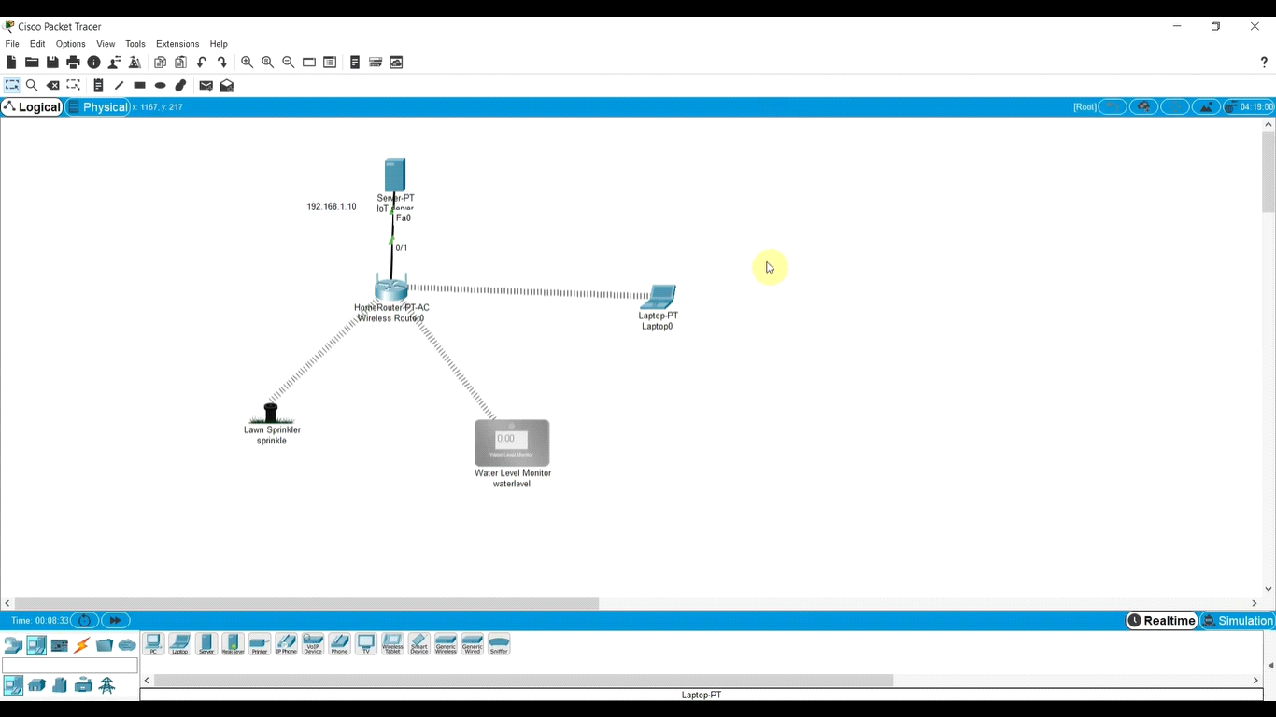

13.IOT Devices in Networking Using Cisco Packet Tracer

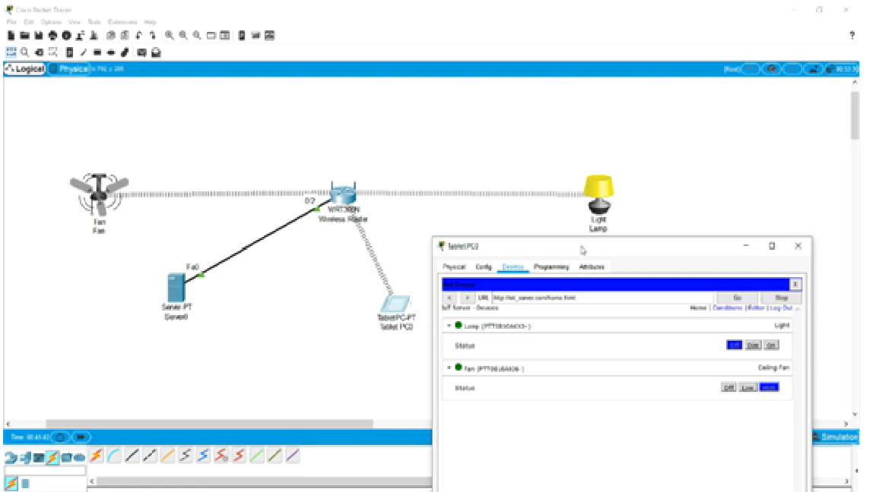

14.Simulating X,Y,Z Company Network Design

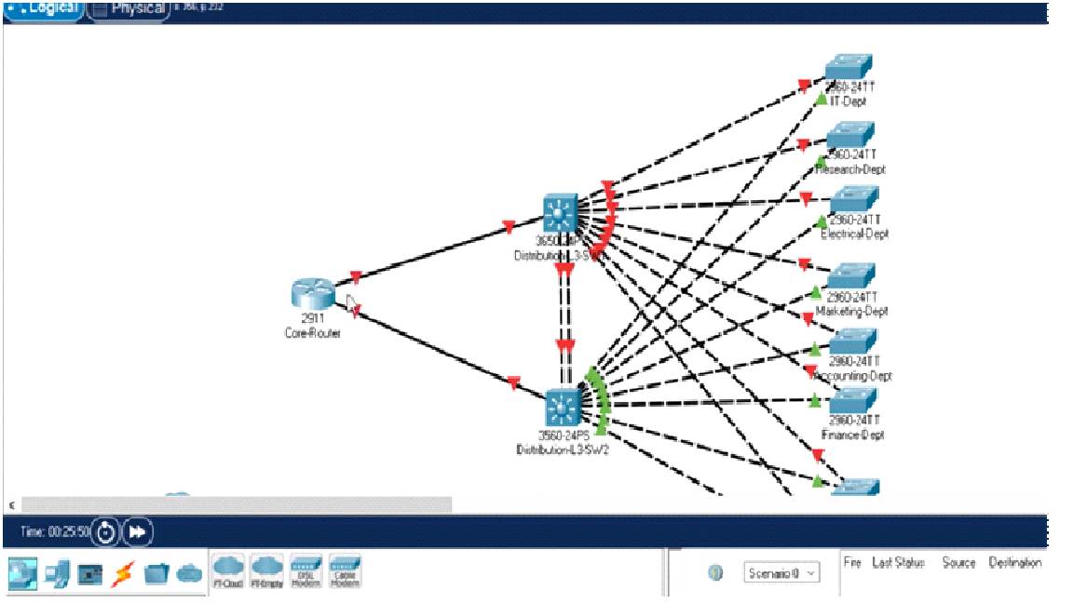

15.Make Computer Lab in Cisco Packet Tracer

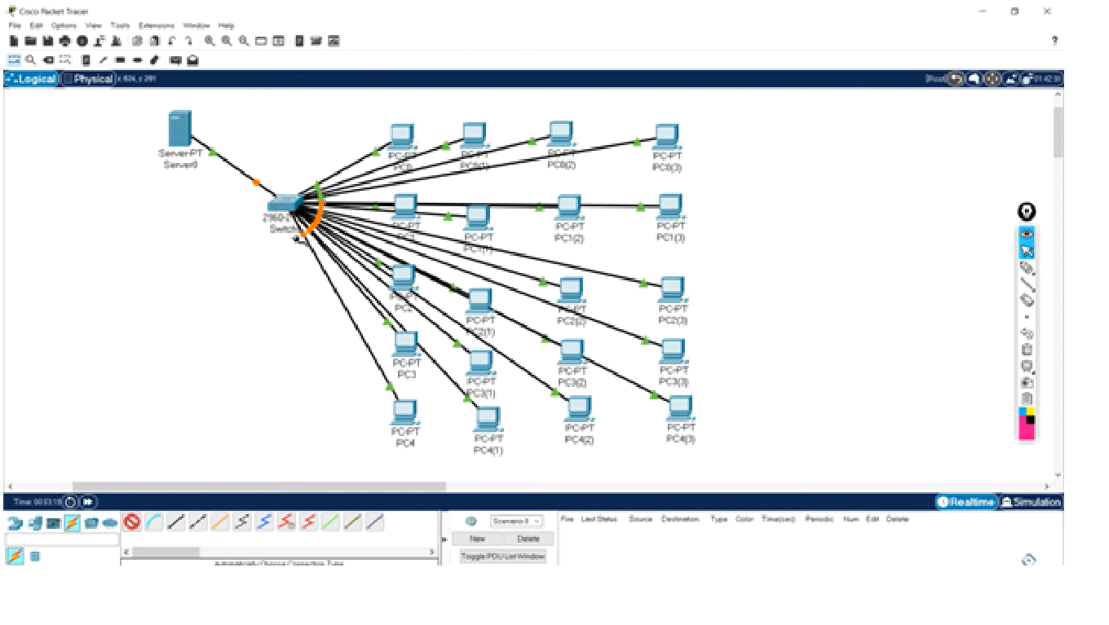

16.Simulate a Multimedia Network

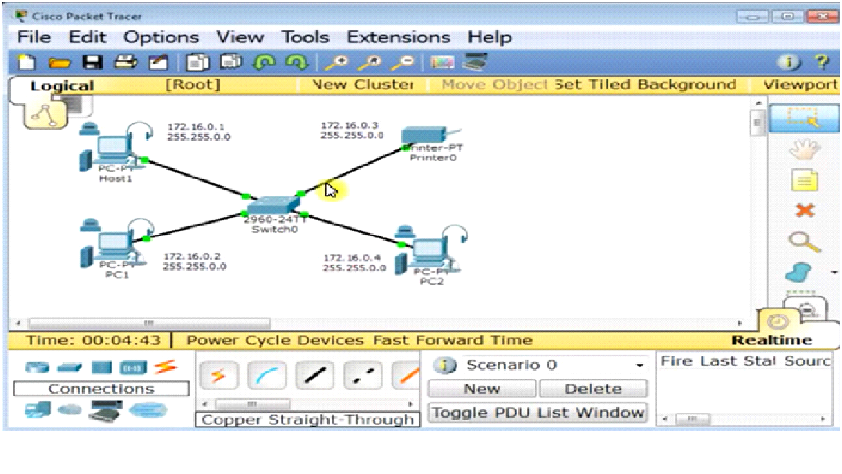

17.AAA Local & Server Based Authentication Configuration in Cisco Packet Tracer

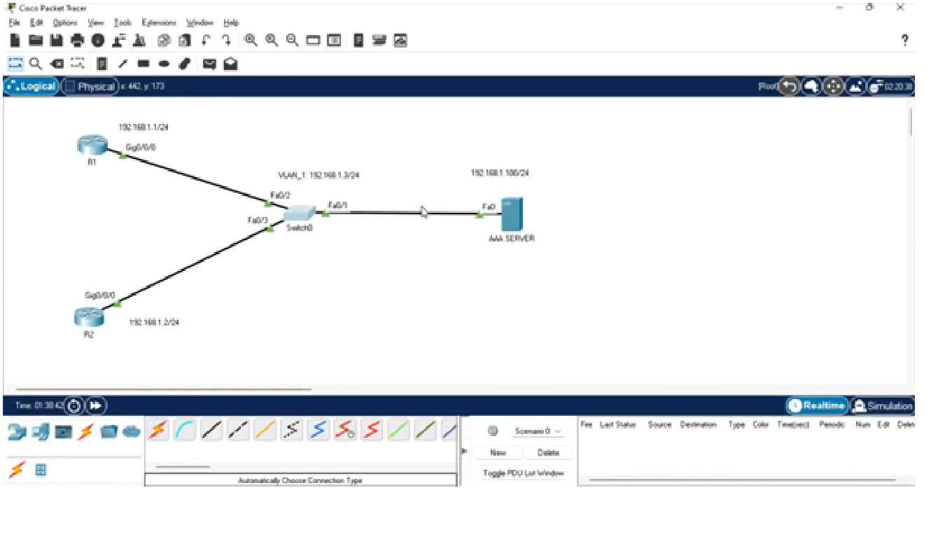

18.IOT Based Smart Home using WPA Security & Radius Server

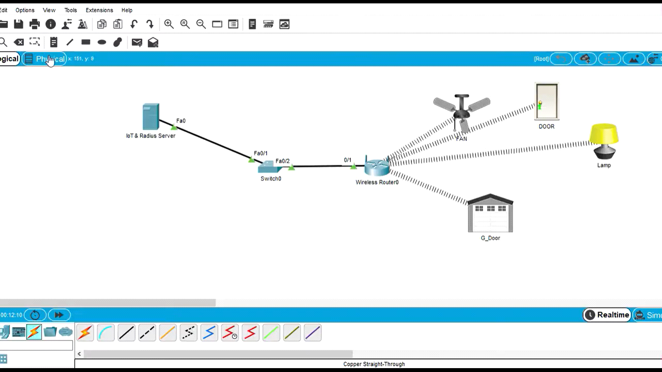

19.WLAN Using Cisco Packet Tracer

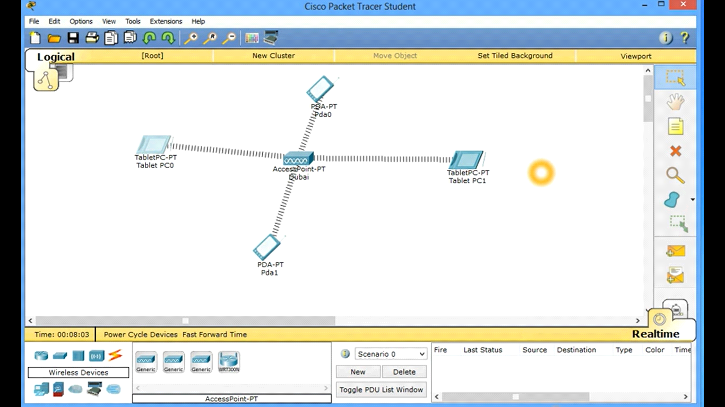

20.Control of Fan, Light, Window & Application of Using Cisco Packet Tracer

